Текст для перекладу

Прізвище, ім’я, по-батькові студента
факультет, група
контактний телефон, електронна адреса
прізвище та ініціали викладача ПКАМ/ІМПС/Практика перекладу

Rain
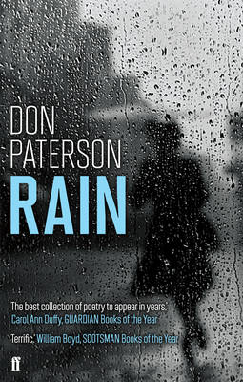
I love all films that start with rain:
rain, braiding a windowpane
or darkening a hung-out dress
or streaming down her upturned face;

one big thundering downpour
right through the empty script and score
before the act, before the blame,
before the lens pulls through the frame

to where the woman sits alone
beside a silent telephone
or the dress lies ruined on the grass
or the girl walks off the overpass,

and all things flow out from that source
along their fatal watercourse.
However bad or overlong
such a film can do no wrong,

so when his native twang shows through
or when the boom dips into view
or when her speech starts to betray
its adaptation from the play,

I think to when we opened cold
on a starlit gutter, running gold
with the neon drugstore sign
and I'd read into its blazing line:

forget the ink, the milk, the blood—
all was washed clean with the flood
we rose up from the falling waters
the fallen rain's own sons and daughters

and none of this, none of this matters.
By Don Patterson

